**Name: merin joseph**

**Roll No:20**

**Batch:b**

**Date:23-5-2022**

**NETWORKING & SYSTEM ADMINISTRATION LAB**

**Experiment No.: 24**

**Aim**

docker installation

**Procedure**

**1.**Remove any [Docker files](https://www.simplilearn.com/tutorials/docker-tutorial/what-is-dockerfile) that are running in the system, using the following command:

$ sudo apt-get remove docker docker-engine docker.io

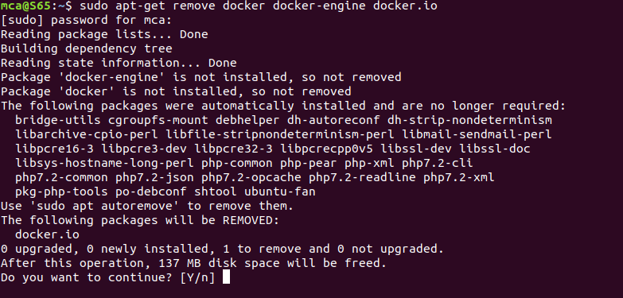After entering the above command, you will need to enter the password of the root and press enter.

**2.**Check if the system is up-to-date using the following command:

$ sudo apt-get update

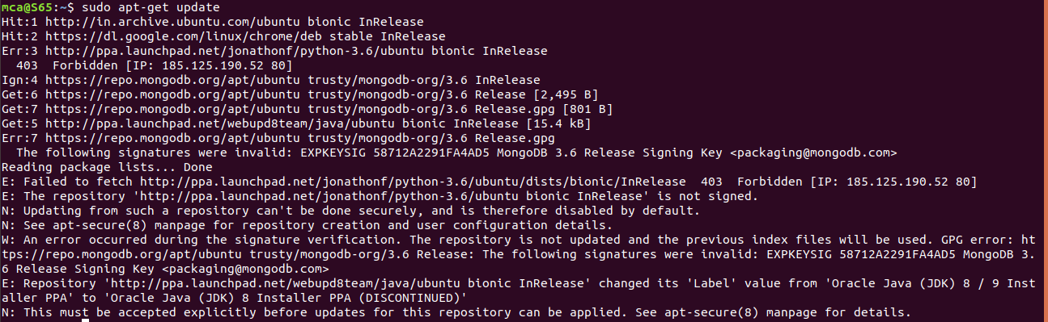

**3**.Install Docker using the following command:

$ sudo apt install docker.io

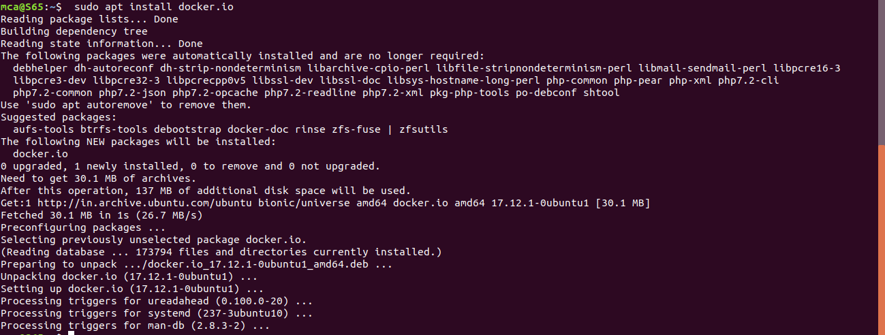

**4.**Install all the dependency packages using the following command:

$ sudo snap install docker

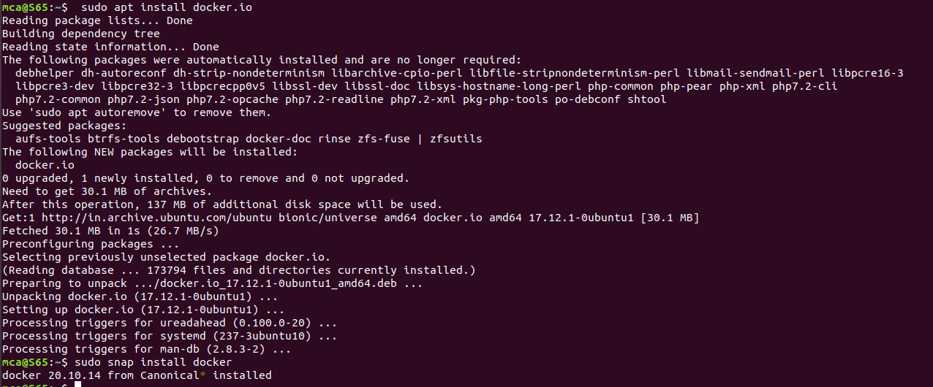

**5.**Before testing Docker, check the version installed using the following command:

**$ docker --version**

6.Pull an image from the Docker hub using the following command:

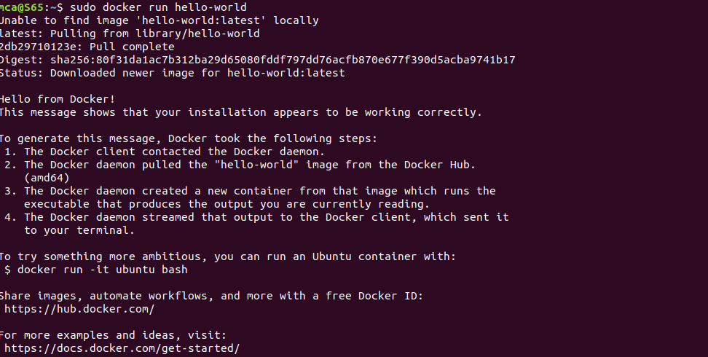$ sudo docker run hello-world

**6**. Check if the docker image has been pulled and is present in your system using the following command:

$ sudo docker images

**7**. To display all the containers pulled, use the following command:

|  |
| --- |
| $ sudo docker p-a |

**8.**To check for containers in a running state, use the following command:

**$ sudo docker ps**

